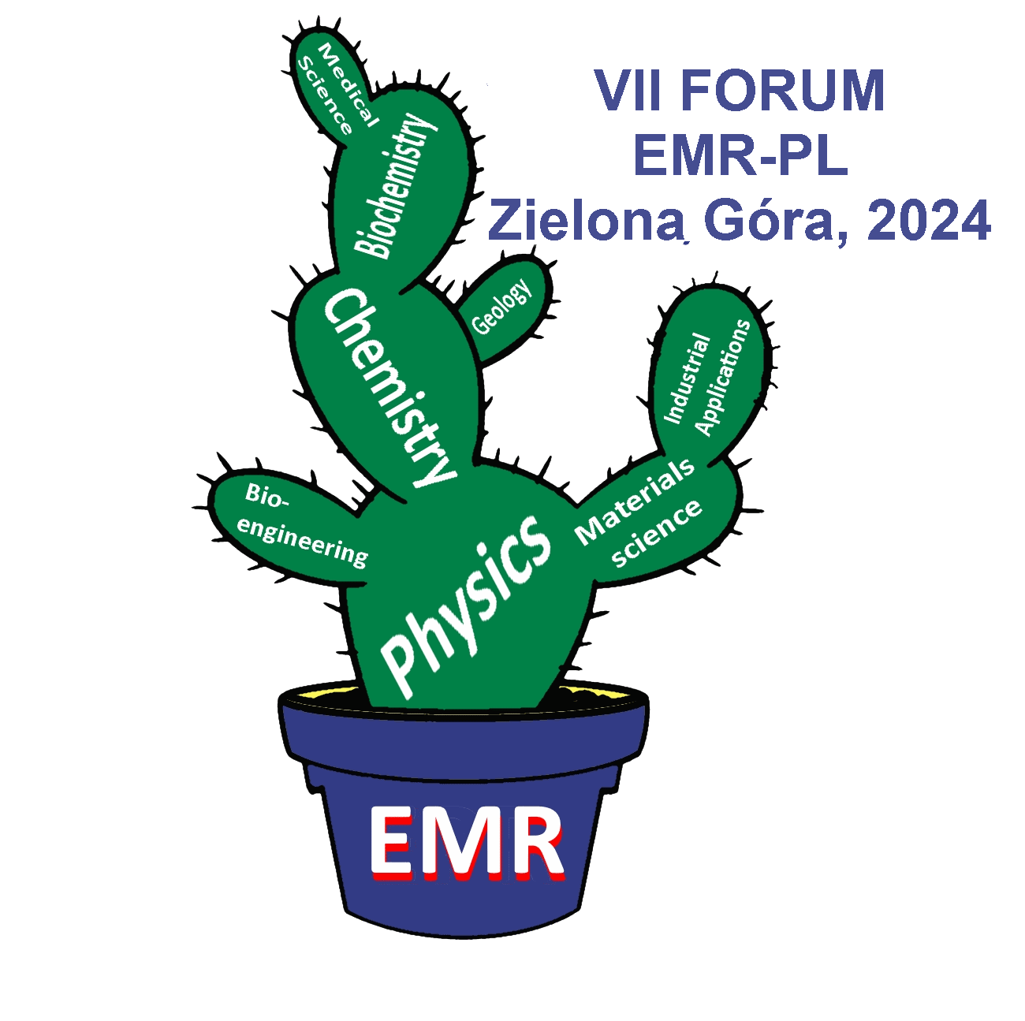 | VII Forum EMR-PL  Zielona Góra, 25-28 June 2024  Poland EMR Group

Registration form

Name and surname:

Title:

Affiliation:

E-mail:

Contact phone:

Invoice data:

Presentation title:

Form of presentation: □ – poster □ – oral

Comments:

Please send the registration form to:

B.Padlyak@if.uz.zgora.pl
e-mail title: „Registration name and surname”

